|  |
| --- |
|  |
| October Newsletter 2022-2023 |
|  |



# Upcoming Events

**October 5, 2022**

Picture Day

**October 7, 2022**

Annual Title I Parent Meeting 9am

**October 11, 2022**

SAC Meeting 4pm

Book Fair Family Night

**October 14, 2022**

Teacher Workday/Student Holiday

**October 24, 2022**

Report Cards released to Parent Portal

|  |
| --- |
|  |
| Support These past few days have been challenging but together we will work as a team to help your student transition back to academic learning. If you have any questions or concerns, please reach out to our school. We are here to help. Thank you for your ongoing support! |

Koa Elementary School

5000 Koa Street Kissimmee, FL 34758

Principal: Michelle Perez Schwartz

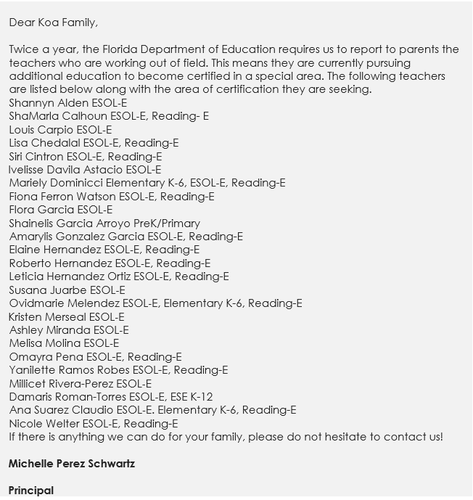

Assistant Principal: Erica Sanders

Phone Number: 407.518.1161

# Academic Corner



|  |
| --- |
|  |
| Stay ConnectedFollow us on Instagram: |

**Check out what your child is learning!**

## Literacy

K-2: Students are working on comparing and contrasting the most important points presented by two text on the same topic. At home, students can read informational text on the same topic and list the things that were the same and different about the two texts.

3-5: Students are working on integrating information from two texts on the same topic in order to write or speak about the subject knowledgeably. At home, the students can read different types of text and explain what details of text 1 and text 2 reveal about the topic.

**Math**

Kindergarten: Students are working on counting, writing, representing and comparing numbers 6-10. At home, practice counting and telling how many.

1st-2nd: Students are using strategies to add and subtract. At home, practice basic addition and subtraction facts.

3rd - 5th: Students are continuing work on place value, multiplication and division. At home, practice multiplication and division facts.

**Science**

Students are working on Earth and Space concepts, including weather, the water cycle, Earth’s surface, day and night, and Earth within the solar system. You can help at home by reading informational texts on these topics and asking your child questions about the information.

# Important Announcement

Would you like a more active role in our school? Would you like your voice to be heard?

**Please join us the first Monday of every month for our School Advisory Council meeting (SAC) at 4:00 in the media center and Zoom.**

Your feedback is very important to us! We look forward to seeing you there.